Report to the Governance Council Lori Longueville
November 2021
Total Hours for Month: 94 (Total Hours Contributed to Date: 499.94 ( 24, 997)
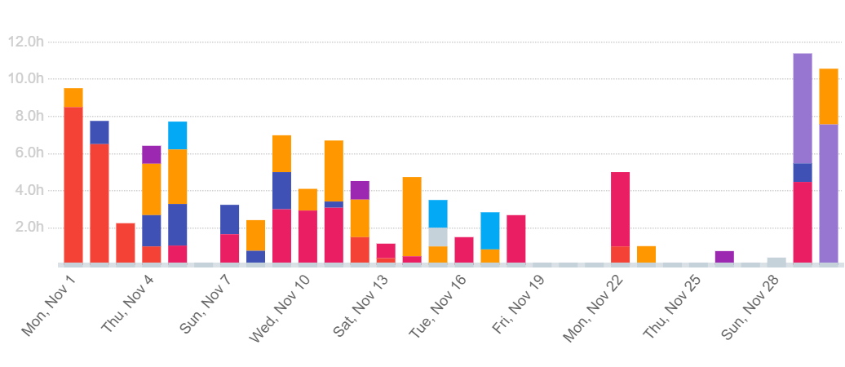
Total Hours Worked:
Breakdown of Hours Worked by Activity
 | # Hours | % of time
Governance | 21:11:24 | 19.78
Screening Collaborative/Il Heals | 10.5128 | 10.13%
Communication | 26.56.36 | 25.14%
SI Families/RSI | 25.33.50 | 23.86%
DHS | 5 | 4.67%
State of Ill  Infrastructure | 2.43 | 2.54%
School Readiness
Not categorized
Other | 1.24 | 1.31%

Activity Summary

Governance/ Communication
- Governance Council meeting November 3rd
- Completed the minutes for the November meeting
- Monthly Governance Council report for November
- Agenda for December meeting , notices and reminders sent out to Council members
- Meeting with Sylvia Cheuy, Tamarack Institute- next steps/ agreement
- Updated In-Kind worksheets 34, 708.14 total of documented in-kind from July 1st through November 31, 2021.

Communication
- Continued work on Coalition website, upload meeting minutes, etc. to match new activity and priorities -
- Updates to SI Families website- articles, Guides, November events, Holiday Help, Community Thanksgiving meals , other : 985 unique visitors, 1626 page views for month.
- Social media posts SI families page-2080 followers, 1951 Likes,138 posts, 1601 page reach, includes event shares Highest ranked posts parenting tips, sharing resources
- Social media posts Coalition Facebook Page – 738 followers,; 66 Likes, 24 posts, 356 post reach

Screening Collaborative/ Il. HEALS
- Co-facilitated meeting November 9th
- Minutes and follow up from meeting
- Updated workplan
- Created informational sheet about participation levels for programs
- Update agreement for collaborative partner identifying levels of engagement
- Began draft of newsletter

Strong Families/ RSI
- Carbondale Children’s Cabinet- meeting Nov 9th
- Minutes of Cabinet meetings
- Co-facilitated Action Team Meeting Toni K Wright
- Minutes from November 18th meeting
- Meeting with Superintendent G Frehener- Johnson County to plan for January 3rd meeting
- Write up information/ decision making
- Carbondale Children’s Cabinet Meeting November 29th

State Infrastructure

School Readiness- no activity

OTHER
- IDHS policy work group -policy review and updates to policy manual, weekly meetings

Holiday- November 25th and 26th

