Report to the Governance Council Lori Longueville
February 1 2022 through March 31,2022
Total Volunteer Hours for the Two-Month Period : 59.09 ($2954.50)

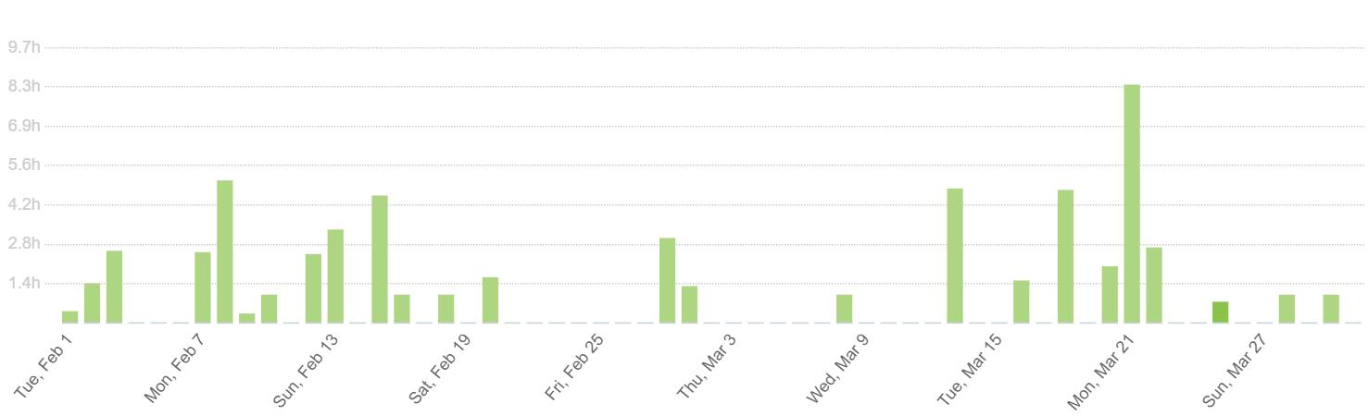
These hours are exclusively for Coalition duties and do not include any work for Birth to Five Illinois.
Total Hours Worked: *
Breakdown of Hours Worked by Activity
 | # Hours | % of time
Governance | 7.14 | 12.24%
Screening Collaborative/Il Heals | 20.12 | 25.15%
Communication | 4.18 | 7.27%
SI Families/RSI | 25.54 | 43.8%
DHS | .45 | 1.27
School Readiness | .45 | 1.27%

Activity Summary

Governance/ Communication
- Completed the minutes for the February
- Monthly Governance Council report for February and March
- Agenda for April meeting , notices and reminders sent out to Council members
- Follow up Meeting with Sylvia Cheuy, Tamarack Institute- sent copy of screening collaborative
- Updated In-Kind worksheets
- Finalized bylaws with approved changes- uploaded meeting documents to website
Created google doc storage files for Coalition documents
- Attempted phone call for follow up with IRS- too much call volume, not accepting calls.

Communication
- Updated email lists in Constant Contact- currently have 2900 + emails including child care, elementary principals, superintendents, economic development, Coalition participants,
Housing Authority and libraries. Working on child welfare, faith community,
- Coalition website updates upload meeting minutes, etc.
- Updates to SI Families website- 1580 unique visitors, 2450 page views ( increased)
- Social media posts SI families page-2040 followers ( decrease), 1965 Likes (increased), 65 posts, 6086 people reached,
- Social media posts Coalition Facebook Page – 752 followers,(increase) 668 Likes, (same) 31 posts ( increase) 1173 post reached ( increase)

Screening Collaborative/ Il. HEALS
- Co-facilitated meeting March 22nd
- Minutes and required follow up from January meeting
- Data updates
- Researched innovation ideas for community of practice
- Entered permission to screen forms into ASQ
- Communication with screening partners
- Meeting calendar evites, reminders, upload workplans to google docs for input by members, reformat and update workplan
- Agenda and materials for March 22 meeting in
- Update Il Heals workplan for quarterly reporting

Strong Families/ RSI
- Agendas/ minutes/ materials for Children’s Cabinet meetings
- Created Agreement with City for Children’s Cabinet
- Created draft Charter for Cabinet
- Participated in Harvard By All Means Call
- Facilitated Cabinet meetings in February and March
- Co-facilitated Strong Families Action Team Meetings- February and March with Toni K Wright
- Minutes from Strong Families meeting, agendas and materials for meetings
- Meeting calendar evites, reminders, upload workplans to google docs for input by members, reformat and update workplan
- Update RSI workplan for quarterly reporting
School Readiness-
- Meeting with Sylvia to discuss committee needs
- Attended meeting 3/25/22

