
Community Survey Results: January 2021
From November 10, 2020 through December 31, 2020, the Southern Illinois Coalition for Children and Families conducted an online survey of residents in the southern fifteen counties in Illinois. The purpose of the survey was to help better understand the challenges children and families are facing in accessing the programs and services they want and need. Survey results will be used to help prioritize the Coalition’s efforts in building a well-coordinated, cross sector system to support young children and their families. We thank those who took the time to complete the survey and are excited to share the detailed results below.
Who Responded?
The Coalition received a total of 201 responses to the online survey. Responses were received from all 15 counties and in relative proportion to the county’s populations. The largest response came from individuals in Williamson county ( 43%). Women were the largest group of respondents. In terms of age, with just under one-third (32.66%) of the respondents reported their age between 32 and were between the ages of thirty-two (32) to forty-four (44). A more detailed breakdown of the responses follows.
Responses by County  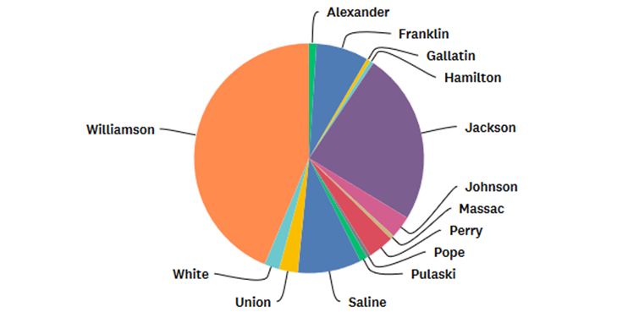 | Response by Age  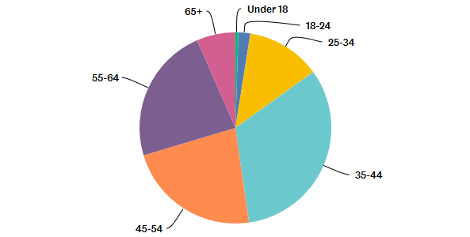
Response by Age  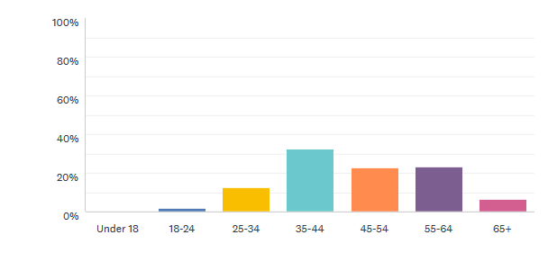 | Response by Gender  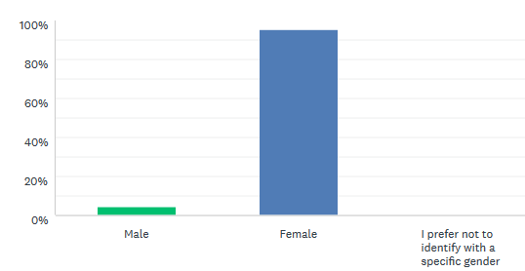
Race and Ethnicity: Even after extending the timeline the survey was open and resending to key partners for distribution, survey results did not represent the diversity of the region. 91.4% of the survey respondents were white/ Caucasian. 5.97% of the respondents identified themselves as Black or African American and only 1.49% identified themselves as Hispanic or Latino. The remaining respondents identified as American Indian or Alaska Native (.5%), other race (.5%) and 1 individual chose not to identify themselves by race at all.
When defining their households, respondents answered as follows:
Total Household Size  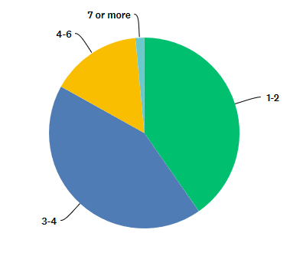 | Household Status  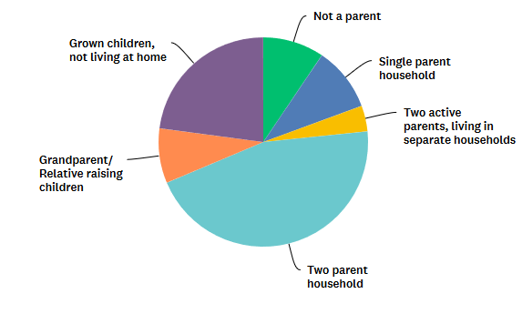
Has a Child with Special Needs  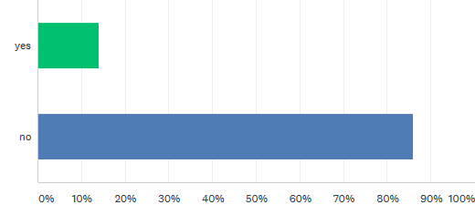 | Ages of Children in the Household  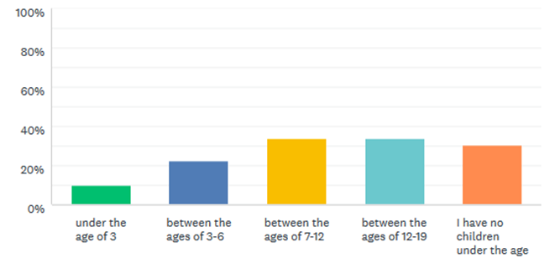

A relatively small number of respondents (34 or 16.91%) reported a family size greater than four. Ane equal number of respondents (34.04%) reported children in their homes between the age of seven to twelve and ages twelve to nineteen. A large number of survey respondents reported no children under the age of nineteen in their households.
Occupations: Respondent reported working a variety of different jobs and vocations that may have some impact on their responses. Among the greatest sectors represented included educators, social work and social service professionals, medical professionals, office and business professionals and community representatives such as librarians and civic leaders. A severely under represented group include stay and home moms and those who are currently unemployed.
What Did They Tell Us?
Children’s Health
What do you think are the top 3 issues that should be addressed by the Coalition in terms of children's health? If something you feel important is not listed, please add it to the list.
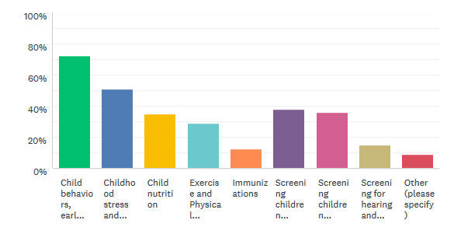

Other health needs identified included counseling for children who have been abused, child sexual abuse prevention and awareness, better access to autism screenings, screening for sensory disorders, services for neuro-atypical kids, teaching coping, assertiveness and refusal skills, and personal safety education, dental care (both exams and treatment) childhood and family obesity, excessive screen time and parent education.
Early Learning and School Readiness
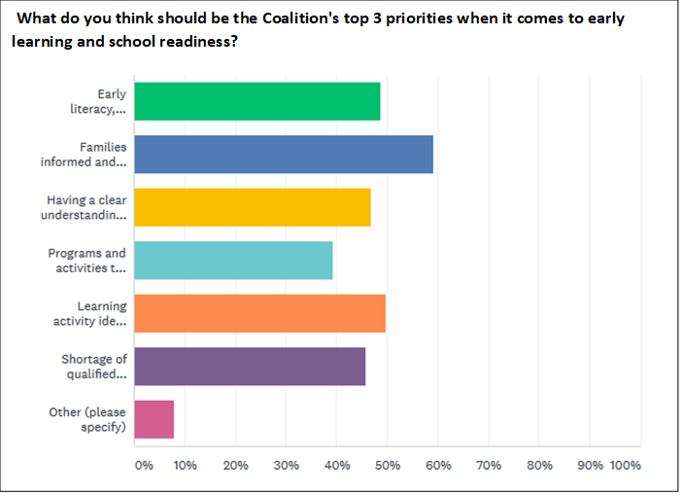
Other needs identified included help for children from low income families, screening, access to FREE early learning programs, personal body safety, and working with families in the home - helping parents learn how to interact with their children that will include helping the child learn through play. Parents that are given "more work" to do with their children will not do it without in-person guidance. Educating parents about school readiness, encouraging family involvement, online support for early learners, early literacy and free play were also noted as critical to school readiness.
Strong Families
From your perspective, what are the three biggest concerns/ needs for families in your community?
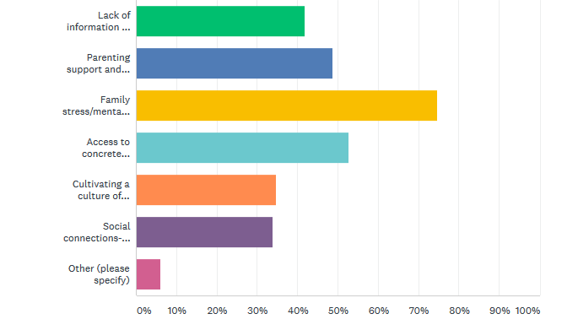

Other issues identified included transportation, lack of knowledge and understanding about mental health needs/ symptoms, addiction treatment and mental health interventions, and pediatric psychiatry. Several respondents mentioned the need for more parent education, on a variety of different subject including proper vehicle restraints, and school involvement and engagement in their child’s learning. Overall resources to provide family stability and resources for special family needs ( such as Christmas) was also identified.
Overall Comments:
Thirty-one (32) respondents made additional comments and/ or suggestion. Many were general in nature but three specific issue areas were identified. They included:
Social Emotional Development/ Mental Health
- social emotional needs for children and families need to be a priority and self-care for staff is also important.
- Need for 3 tier intervention in child care centers for academics and behavioral.
- Our schools and communities need councilors who are well informed with the subject of childhood anxiety, panic disorders, social phobias, etc.
- I see so many children in my school who are being raised by screens or whose screen time is not being monitored effectively. Parent education regarding this (and how to manage it, what alternatives there are) would be helpful. I understand that there are more critical needs for some children who are dealing with bigger problems, but the device addiction is widespread and so problematic for brain development.
- We very desperately need more mental health providers that specialize with children in this area
- Would love to see more mental health services for parents/families - closest MH provider is 20 mins away in Eldorado and parents are already overwhelmed. Gentle parenting/discipline seems to be a need here. Which is tied into having mental health services for parents available.
Child Care Access/ Quality and Access
- City leaders need to do more to connect with the general public and families in particular

- I the "qualified staff" requirement has put daycare facilities in a tough bind, because they cannot pay a teacher qualified staff enough or provide benefits that someone with a college degree should earn. Children can learn best from parents that are involved with them - not shipped off to a daycare. Today's parents need to be trained to be parents that will educate their children through play. What is to be gained by institutionalizing children from birth??? Hasn't really worked in the U.S. so far. Funding for early childhood education needs to be made available for a larger population than just the lower incomes. Funding needs to go to the facilities and programs such as Head Start to reach the at-risk children - including children that may not meet the poverty bracket.

- I feel that there is not enough collaboration between the school system and child care centers on what is needed to have children successfully transfer from a child care setting to a public-school system. Child care teachers are not considerate educators in the eyes of public-school teachers.

- Having qualified teaching staff is a huge issue in our area. Those of us whom are qualified are plugged into anything and everything because we are some of the few still concerned and interested in Quality Childcare and teaching young children. With Colleges getting rid of there ECE programs and Counselors not promoting ECE soon we will be left without any teachers. DCFS as you know has qualifications to be a Teacher or Director. No one is going into those programs because students are not being given the information and benefits of working in the childcare industry. I do see so many positive changes and feel the government and those who support us are moving in the right direction. But something has to be done now.

- More affordable all-day child-care programs for preK children.
- We need more awareness of the childcare shortages in the area brought to the attention of city leaders. This is a growing problem that entire communities need to step up and address. Awareness would hopefully emphasize the impact on workforce and local economies. It was a problem before COVID and it's an even bigger problem now.

Parenting/ Family Education
- In all respect I see children that are being raised to stay children with no encouragement for attaining self-help skills. They are unaware of their surroundings and how to act with other children.
- Since Chromebooks have been intertwined with school the Parent to Teacher communication has disappeared. My son is in the 10th grade and from the 6th grade till now I have been contacted and I also work in the MU2 district. My 9yr old granddaughter can read better than my son yet in 9th grade he asked his Teacher to be removed from Reading Enrichment they did so and I was NEVER contacted! Really, he failed English in the 8th grade and that's ok!? As a parent I feel helpless. As a employee I'm ashamed.

- It is essential for parents and children to have the support available to help them succeed, especially now as we deal with the ongoing pandemic and the repercussions emotionally, psychologically, financially, physically, etc. Helping build the foundation with love and support from many areas and addressing the necessities that are needed is imperative for our families to thrive. We have come a long way, but still have much more to go. There are so many various family units, styles, cultures, etc, and coming up with a culturally sensitive approach is so important. Thank you for wanting to gather information, help, and have our voice heard.

What Comes Next?

Now that the survey has closed and results have been collected, the Coalition will be conducting 3 special “though partner” sessions with community representatives and leaders to determine what should be the Coalition’s focus/ priorities for the next three years. The “thought partner” sessions will be held via zoom and facilitated by a representative from the Tamarack Institute of Canada. Tamarack is a world leader in collective impact and community change.

Each thought partner sessions will focus on one area only.

The sessions are scheduled as follows:

February 10th 9:30 am- 11:00 am STRONG FAMILIES

February 17th 9:30 am- 11:00 am SCHOOL READINESS

February 24th9:30 am- 11:00 am CHILDREN’S HEALTH

Anyone interested in attending should contact the Coalition at southernillinoiscoalition@gmail.com .

